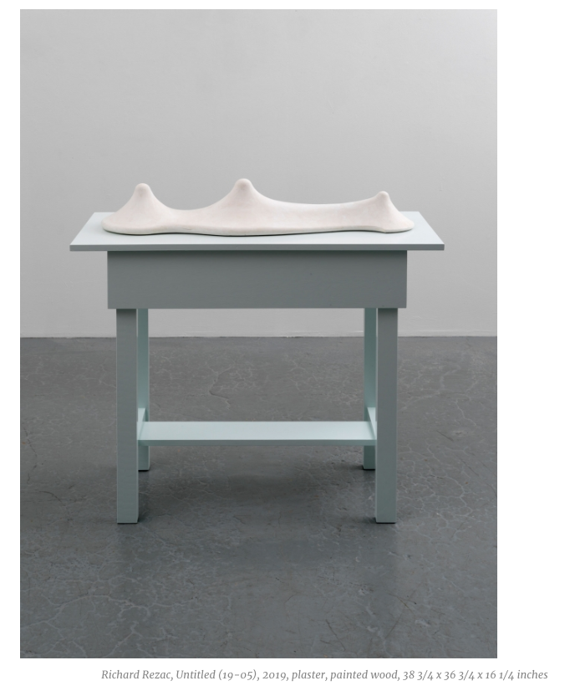

Contributed by Rachel Youens / Richard Rezac, a Chicago-based sculptor, is having his first solo show at Luhring Augustine Chelsea. Rezac’s abstract sculptures are supra-sensual forms. His method of slow, deliberate decision-making yields a heightened sensuality that suggests many things at once. Standing on the floor or in corners, hung on walls at different heights, or suspended from ceilings, his work is purposefully disorienting, opening the viewer to novel perceptions.

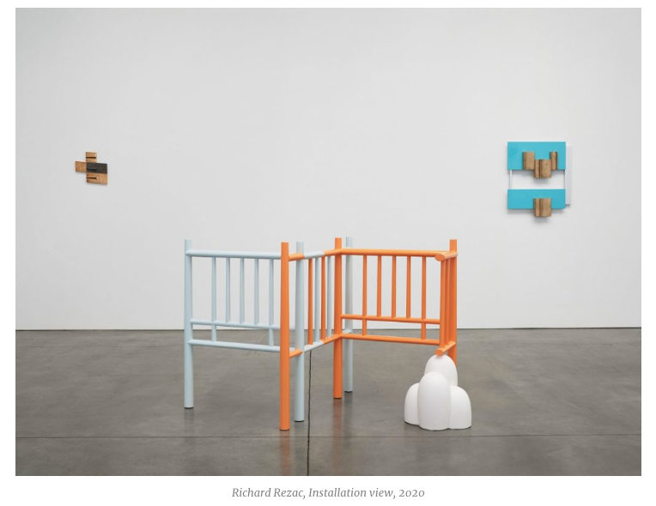
At modest scale and arm’s-length reach, it reflects and encourages expansive impulses. Rezac pursues proportionate asymmetries, yet the particularity of his work embodies both grandeur and domesticity. His materials, keyed to the “ages of man,” evoke glimpses of cultural memory, while his consideration of planar relief and colored surfaces point to his ongoing engagement with painting.

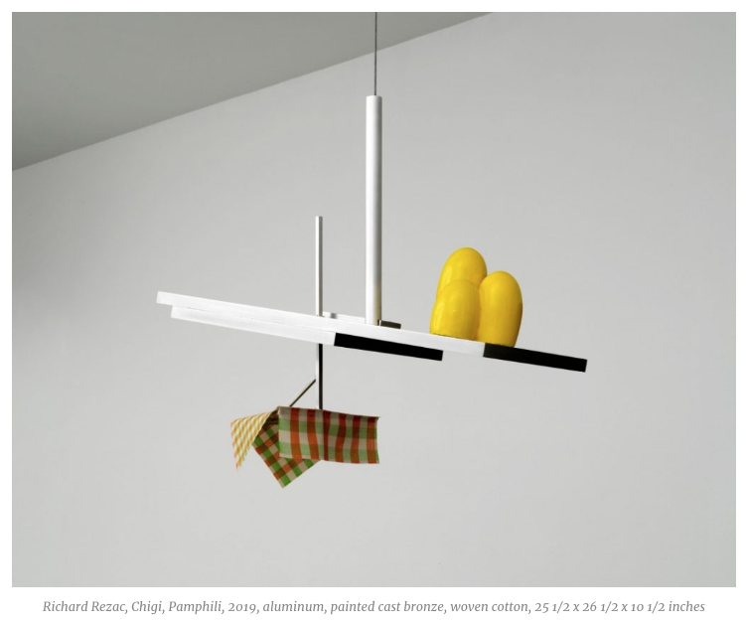
Through various motifs, Rezac questions and addresses the problems of articulation and elision within formal and metaphorical relationships. One favored theme is based on framings, moldings, and enclosures; another involves the interactive pairing of volumetric forms on tables. Several works in the show relate to the Baroque architect Francesco Borromini and others Rezac studied during a recent residency at the American Academy of Rome. Rezac’s aesthetic logic appropriately resists clear, easy conclusions. His affinity for structure and artisanal materiality leads to distilled syntheses of form, prompting us to assess his intriguing propositions with engaged, extended looking.
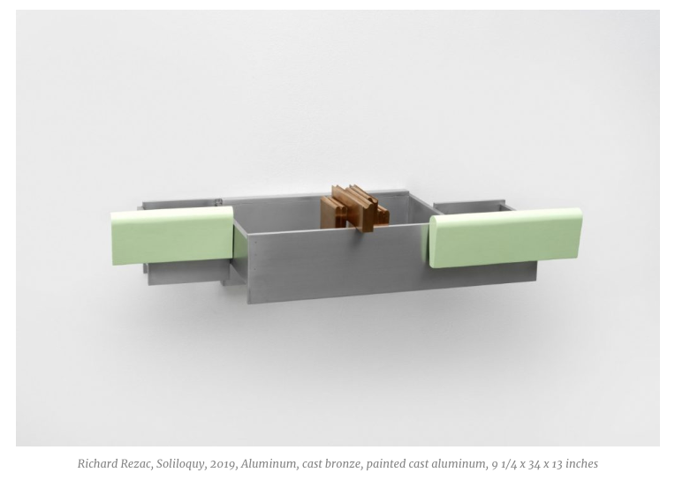
In Soliloquy, a molding form is personified so as to rest on a projecting cantilevered enclosure space, which in turn is articulated by volumetric light-green forms. Rezac’s contrasts of cool burnished aluminum and hot bronze casting intensify its theatrical subject. Chigi stands on the floor. Furniture-like, the work’s vernacular railings, set at axial angles, shift between ambiguity and illusion; its painted rails of sharp, contoured orange are interspersed with pastel blue countersignals. He gives abstract works precise chronological dates for a reason. Untitled (20-01) and Untitled (20-02), for instance, are iterative works in which Rezac re-contextualizes castings of large-scale molding fragments within differently framed planar reliefs.

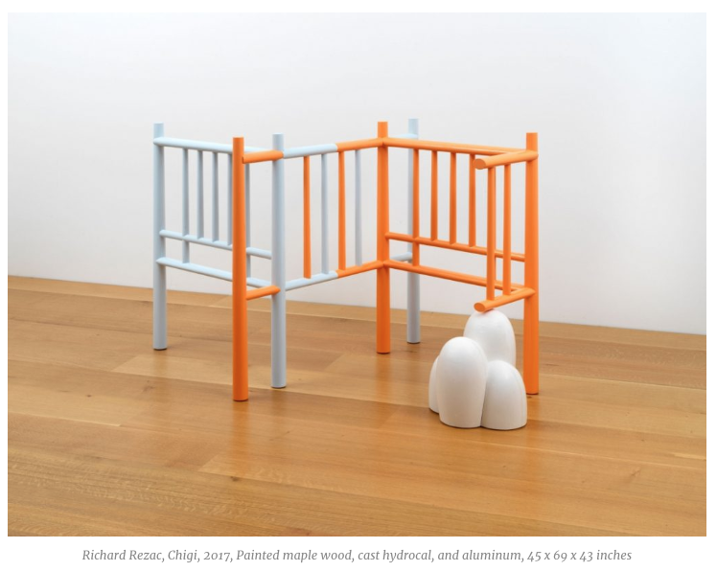

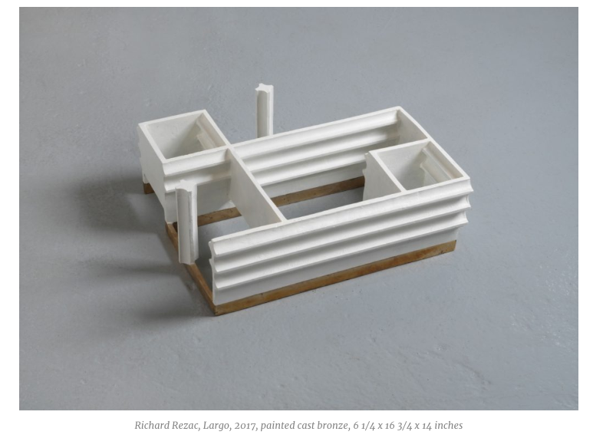

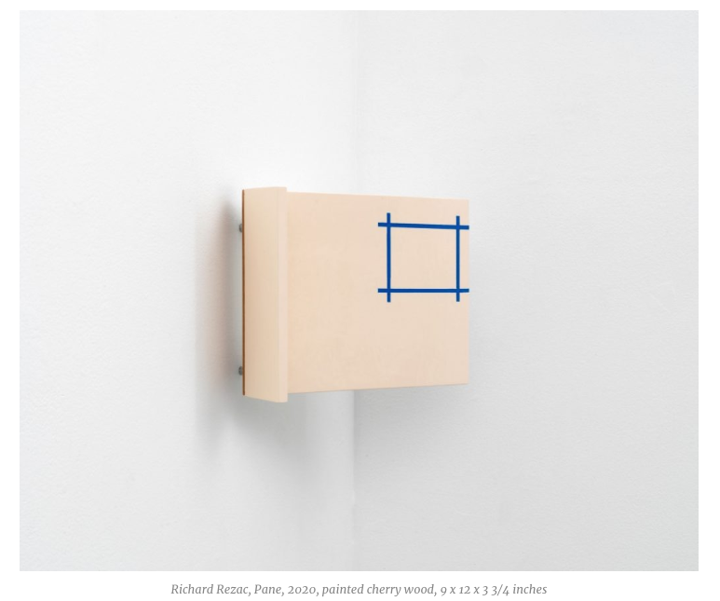

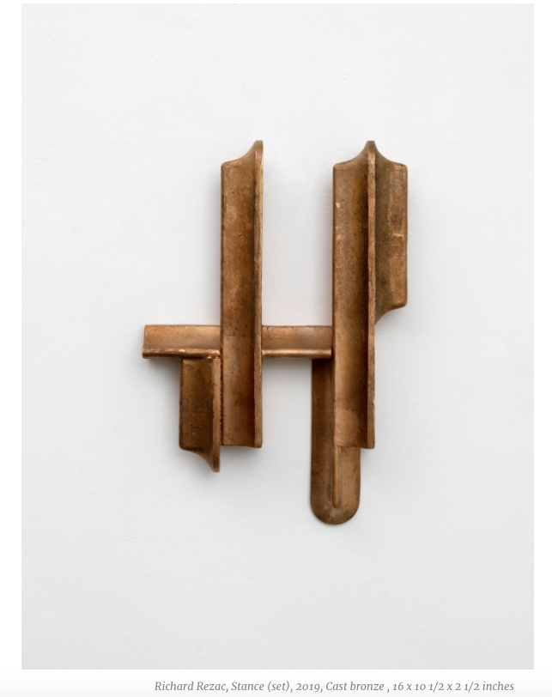

Chigi, Pamphili, referencing a Roman chapel turned mausoleum, is an iconographic work and the exhibition’s culminating piece. Made of silvery matte aluminum, suspended from the ceiling and ascending at an angle, its essential form is that of a roof or altar. At one side it is weighted with radiant yellow egg-like forms. From the other, a vertical rod slips into the space below to connect with a small table, draped with a woven checkerboard cloth. Nearby, a cast bronze work, Stance (set), embodies six variations on simple molding profiles joined at 90-degree angles, the vertical and horizontal articulations evoking a skeletal buttress. In the same small room, Untitled (19-05), a white volumetric silhouette on a pastel blue table, rhymes with another work in the adjoining room, which now seem like mountains in the distance. This is a compelling show: searching, never forced, and always coherent.
“Richard Rezac,” Luhring Augustine Chelsea, 531 W. 24th Street, New York, NY 10011. Closed due to Covid-19.
About the author: Rachel Youens is an accomplished painter, a graduate of the Art Institute of Chicago BFA program, with an MFA from Brooklyn College, where she studied with Lois Dodd, John Walker, and the late Jack Whitten and Lennart Anderson. She has had numerous shows in NYC, most recently at Valentine Gallery in Ridgewood. Youens teaches at Parsons School of Design, The New School, and at LaGuardia Community College.

