Black History Month

MAYOR LIGHTFOOT HONORS CHICAGO’S BLACK COMMUNITY LEADERS
Site Editor: February 26, 2021
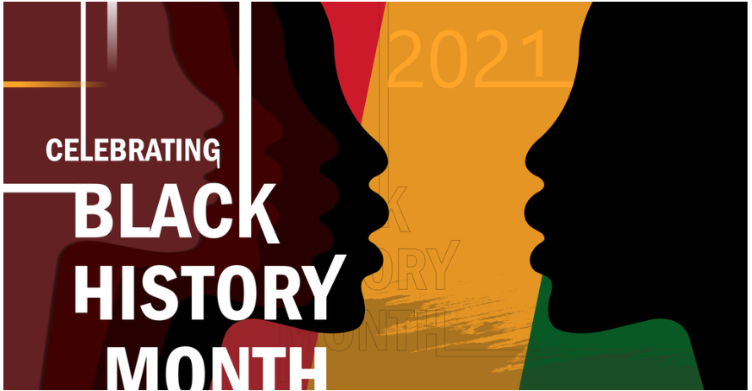
Mayor Lori E. Lightfoot will join the Mayor’s Office of Community Engagement and other City leaders for a celebratory virtual event to commemorate Black History Month by honoring 20 Black community leaders for their commitment to supporting and advocating for Chicago’s dynamic Black residents.
“As a Black woman, mother and Mayor, Black History Month provides me with an opportunity to reflect on the ways in which I can better the lives and uplift those who look like me or share similar experiences,” said Mayor Lightfoot. “Each of the individuals and organizations we’re celebrating tonight have and continue to do just that by serving as long-time champions and advocates for Black communities both near and far and leaving a deeply positive impact on our city’s social and economic landscape. It is my honor to celebrate their accomplishments this evening and I thank them for their continued efforts to improve our city from the inside out.”
Recipients were selected based on their leadership and contribution to the Black community through various industries, including art and culture, health and medicine, technology, business, community empowerment, civil rights, education, youth outreach, and immigration rights. While the work of these individuals has always been important, their dedication has been vital in overcoming significant challenges facing minority communities due to the COVID-19 pandemic, rising racial injustice and calls for change.
“As a proud Black man and Chairman of the City Council’s Black Caucus, we are excited to honor the contributions of these remarkable leaders,” said 28th Ward Alderman Jason C. Ervin. “Our history, which often goes overlooked, is the foundation of what makes our diverse and thriving city so great. We look forward to continuing our work with the Mayor and community leaders to advocate for our Black residents.”
“I am thrilled to commemorate the many Chicagoans that make me proud to be a Black woman,” said 8th Ward Alderman Michelle Harris. “These individuals personify the devotion and resilience that is our City’s heritage. Their work made sure their communities were informed, protected, and provided for during these unparalleled times.”
Among the extraordinary leaders honored tonight is legendary Chicago historian and civil rights activist Timuel Black, the Legacy Award recipient.
“I am deeply humbled to receive this honor from Mayor Lightfoot and the great City of Chicago, which I love so dearly,” said Timuel Black. “In all my years of life, I have remained inspired by the leaders whose passion, commitment to our community and shared mission of fighting for equality have advanced the city far beyond what many thoughts could be. It is important that as we look back on our rich history, we continue to support and strengthen our bright future and leaders to come.”
Civil Rights Award
Karen Freeman-Wilson, Chicago Urban League
Community Empowerment Award
Karl Brinson, Westside NAACP
LGBTQ+ Activism Award
LaSaia Wade, Brave Space Alliance
Immigrant Rights Award
Fasika Alem, Ph.D., United African Organization
Health and Wellness Award
Morris Reed, Esq., Westside Health Authority
Youth Award
Pha’Tal Perkins, Think Outside Da Block
Arts and Culture Award
Cecil McDonald, Clifton Henri, Nick Cave, Dorian Sylvain, Candace Hunter, Amanda Williams, Damon Locks, Tonika Johnson, and Okunola Jeyifous
Environment Justice Award
Naomi Davis, Blacks in Green
Business Award
Danielle Mullen Ph.D., Semi-Colon Bookstore
Technology Award
Patrice Darby Neely, GoLogic Solutions
Education Award
Zaldwaynaka “Z” Scott, Esq., Chicago State University
Legacy Award
Timuel Black, Chicago Historian
The City of Chicago will provide a livestream feed of the event on Mayor Lightfoot’s social media channels including Facebook and Twitter.

